**Sign up Page**

1. We Need Phone no. with cuntory code like current eindia sign up page ,whenever customer enter their country name, theirphn code also updated in phone coloumn according to country

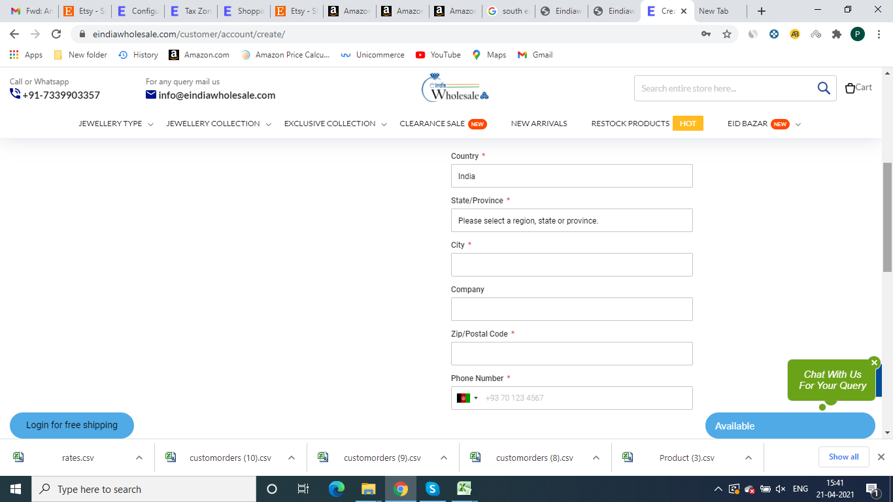

1. We Need Address column on Sign up page like current website
2. We need separate column for Country, City State and zipcode, bcz shipping is calculated through Country code ,
3. In phone no. tab country flag is visible and country phone code is auto fulfil when customer enter his country
4. Need a column for GSt No Detail ( not compulsory )